LifeSci 2N03 Assignment #2
What Are You Eating – A Dietary Assessment

Jatin Chowdhary
Department of Science, McMaster University
LifeSci 2N03: Human Nutrition For Life Science
Dr. Shelley Vanderhout
November 8th, 2021

Author Note
Jatin Chowdhary is a student at McMaster University
I have no conflicts of interest to disclose
I would like to thank Dr. Vanderhout

Part E – Written Interpretation
1a. As per Diet Wellness Plus (DWP), my average kilocaloric intake, per day, is roughly 2387.9 kcal, and my calculated estimated energy requirement (EER) is 2667.00802 kilocalories. Dividing the former value by the latter yields ~0.895, and multiplying by 100 percent yields roughly ~89.5%. On average, I am meeting about ~90% of my caloric intake. Although it is not 100%, or very close to it, a discrepancy of 10% is acceptable due to shortcomings and inadequacies in Diet Wellness Plus. It is likely that the software is under reporting calories for some foods, namely carbohydrates. The software takes into account the average portion size, but my portions are at least 20% larger than the average portion size, and there is no way to compare my portions with their default values. Hence, there is a discrepancy between my average kilocaloric intake, per day, and my calculated estimated energy requirement (EER). These results are acceptable.
1b. According to Diet Wellness Plus (DWP), my macronutrient intake for carbohydrates is low, for protein it is very high, and for fat it is a little bit more than my DRI. My fat intake is over the AMDR, because I frequently consume olive oil, peanuts, and use clarified butter when cooking meals. Nonetheless, my fat intake does not pose any serious health risks. On the other hand, my protein intake is way above the AMDR, because I drink whey protein shakes almost every day. In addition, I consume a relatively large amount of meat and eggs during the weekend. Even though Diet Wellness Plus lists this as an issue, the software does not account for my daily physical activity. Protein shakes are only consumed on days where I exercise. If I do not exercise, then I do not consume a protein shake. In addition, if I know ahead of time that dinner involves meat, then I will not consume a protein shake. Plus, if I intend to have eggs, I cut back on how much protein powder I consume. Finally, my macronutrient intake for carbohydrates is low, and this does pose a cause for concern. Carbohydrates are an essential macronutrient for maintaining optimal human health. Carbohydrates contain vitamins, minerals, and most notably, fibre. Fibre is very important. However, upon closer examination, I am not deficient in any vitamin or mineral, and my fibre intake is relatively ok. Thus, I believe that this discrepancy is due to the inadequacies of Diet Wellness Plus. It is probable that the software is under reporting carbohydrates for certain foods, most notably (flat) bread, which is a staple part of my diet.
1c. Overall, my micronutrient intake is optimal relative to the recommended intake (DRI) values. For most micronutrients, my intake is either at par or over the recommended intake (DRI). The only vitamin I am lacking is vitamin D. However, this is because Diet Wellness Plus does not account for sunlight exposure when calculating vitamin D intake or production. Vitamin D can be synthesized via sunlight, but the software only accounts for vitamin D intake or production via diet. Hence, this discrepancy does not pose any reasonable cause for concern.
1d. Compared to recommended water consumption, my water consumption is inadequate by roughly 1 L. This is problematic because water is essential for cells to function. This inadequacy cannot be attributed to the software; it is my fault. On average, I need to drink 5 more cups of water every day to meet the recommended water consumption.
2. Upon comparing my micronutrient intake against the recommended intake values outlined in the "DRI Essential Guide", it is evident that I am overconsuming vitamin B12 and iron, and lacking in vitamin D, potassium, and sodium.
My overconsumption of vitamin B12 is due to daily supplementation. I frequently take vitamin B12 in the form of methylcobalamin in the morning with a whey-based protein shake and a banana. The recommended intake (DRI) for vitamin B12, for an individual like me, is 2.4 mg/day. My intake is roughly 400.4 mg/day. According to scientific literature, overconsuming vitamin B12 is not an issue because it is water soluble and most of it is excreted in urine (Water-soluble vitamins: B-complex and vitamin C 2012). In addition, absorption of vitamin B12 is not 100% efficient due to the need for an intrinsic factor. Hence, my overconsumption of vitamin B12 dose not pose a serious issue. In contrast, vitamin B12 deficiency poses a serious health risk – especially for vegetarians. Symptoms include, but are not limited to, neurological disease, anemia, impaired cognition, fatigue, thrombosis, gastritis, etc. (Vitamin B12 deficiency 2013). Therefore, my overconsumption of vitamin B12 is not a serious issue, but it would be wise for me to supplement on alternate days.
My overconsumption of iron is due to the heaps of vegetables – mostly broccoli – whole grains, and nuts I consume on a daily basis. The recommended intake (DRI) for iron, for an individual like me, is 8.00 mg/day. On average, my daily intake of iron is approximately 15.98 mg/day – this is almost twice the DRI. Overconsumption of iron can negatively impact my health via inflammation, anemias, neurodegeneration, thalassemias, and oxygen tension (Iron overload in human disease 2012). However, an important thing to note is that most of my iron comes from plants, grains, and nuts, which is heme iron. Heme iron is less bioavailable than its counterpart non-heme iron (Dietary heme iron absorption 1979). According to the literature, heme iron consumption does not equate to absorption.
According to Diet Wellness Plus, I am severely lacking in vitamin D. My calculated intake is 1.011 mcg, and the recommended intake (DRI) is 15.00 mcg. This is unacceptable because vitamin D is essential for optimal human health. Research has shown that vitamin D deficiency is "associated with increased risk of common cancers, autoimmune diseases, hypertension, and infectious diseases" (Holick et al., Vitamin D deficiency: a worldwide problem with health consequences 2008). In fact, vitamin D deficiency is now recognized as a pandemic (Holick et al., 2008). In adults, vitamin D deficiency can "exacerbate osteopenia and osteoporosis, cause osteomalacia and muscle weakness, and increase the risk of fracture" (Holick et al., Vitamin D deficiency 2007). As a young adult this a serious problem. However, Diet Wellness Plus only tracks vitamin D intake via diet, and not vitamin D synthesized by the skin when exposed to sunlight. Therefore, the calculated values may not be entirely accurate due to a major component being excluded. A more accurate test is a blood test, which can precisely determine how much vitamin D is cirulating in the blood.
Finally, my intake of sodium and potassium are inadequate; which is detrimental to my health, due to the critical roles these two minerals are involved in. As per the template, I need to consume 1.3g and 0.9g more of potassium and sodium, respectively. Failure to do so will negatively impact my health by disrupting the sodium-potassium pump. Deficiency in these key minerals can result in hypertension and cardiovascular (The impact of sodium and potassium on hypertension risk 2014).
3. The best way for me to improve my diet is to focus on the few things I am deficient in, namely, water, sodium, potassium, vitamin D, and carbohydrates. The quickest way I can improve my diet is to increase my water intake by 1.4 L/day, which translates to about 6 glasses of water obtained via food and beverages. The most effective and attainable way to achieve this is to drink water out of a 1.5 L (glass) bottle. I can fill up the bottle in the morning and finish it by night. Hence, this will allow me to measurably drink an adequate amount of water in a timely and realistic manner. The single best improvement I can make is by increasing my sodium, potassium, and vitamin D intake. More specifically, I need to start consuming avocados every night in the form of guacamole. Avocados are high in potassium, and guacamole requires salt – sodium. Based on my requirements I can measure how much salt I need as per the recommended intake (DRI). In addition, I can pair the guacamole with organic kettle corn chips, which provide a healthy source of whole grain carbohydrates. The entire snack is healthy, plant-based, good for the planet, and provides all the nutrients I am deficient in. As for vitamin D, I can resort to supplements or consume fatty fish. In the beginning, I can supplement vitamin D, and then switch to fatty fish.
4. Compared to Canada's most recent food guide (2019), my diet is high in protein, and low in carbohydrates and plant-based food. The first way my eatings habits can be improved to better align with Canada's food guide is adding more fruits and vegetables to my diet. CFG recommends trying a variety of fruits and vegetables such as: pears, berries, peaches, cabbages, leafy greens, cauliflower, celery sticks, etc. The second improvement I can make to better align my diet with Canada's food guide is by eating more whole grains. This includes things like: quinoa, pasta, bread, oats, and brown rice. Whole grains are high in fibre, an essential nutrient for optimal human health. The last improvement I can make to my diet is cutting down on protein from whey-based powders, and focusing more on beans, lentils, nuts, and plant-based protein in general. Canada's food guide does not recommend eating large amounts of protein to meet nutritional needs.
5a. Three products I found to have misleading advertising on their packages are: croutons, keto bombs, and fruit snacks. The croutons are made by "Back To Nature", the keto bombs are made by "Keto Made Simple", and the fruit snacks are made by "Welch". The croutons are misleading because the packaging advertises that they are fresh, when they are not. Upon reading the ingredient list, it is immediately obvious that a lot of preservatives are added to retain the product's freshness. In addition, the pictures on the packaging mislead customers into thinking that the croutons are a healthy snack. The keto bombs are misleading because the packaging advertises no sugar, but fails to mention that natural sugar has been replaced with artificial sugar. After reading the ingredients, it is evident that the keto bombs undergo heavy processing, which is counter intuitive to a healthy snack. The packaging on Welch's fruit snacks are misleading because it does not clearly disclose that lots of sugar is added during the production of the snack. The packaging is designed to be as misleading as possible. Most customers associate fruits with healthy eating, and Welchs' fruit snacks take advantage of this via misleading claims and product labels.
5b. Upon closer inspection of the croutons, it is evident that they are not a healthy addition to salad. The most dissauding fact about the croutons is that they are not whole-grain products. In fact, the croutons are refined carbohydrates, which are notorious for lacking key nutrients, and acting as anti-nutrients by prohibiting the absorption of other nutrients (Refined carbohydrates—a cause of suboptimal nutrient intake 1983). The keto bombs are not a healthy snack because the keto diet is an unhealthy fad diet. Research has shown, time and time again, that the keto diet is unhealthy, and poses serious long term health risks (Dietary carbohydrate intake and mortality 2018). Customers would be dissauded from buying keto bombs, if they were aware of the serious health risks with a keto (fad) diet. Finally, Welchs' fruit snacks are extremely misleading because the packaging does not clearly state that sugar is added, nor does it state that the fibre in fruits has been stripped out, along with most of it's nutritional value. If customers knew they that Welchs' fruit snacks are more sugar and starch than fruit and fibre, then they would not purchase it.
References
Adrogué, H. J., & Madias, N. E. (2014, May). The impact of sodium and potassium on hypertension risk. In Seminars in nephrology (Vol. 34, No. 3, pp. 257-272). WB Saunders.
Bellows, L., & Moore, R. (2012). Water-soluble vitamins: B-complex and vitamin C (Doctoral dissertation, Colorado State University. Libraries).
Fleming, R. E., & Ponka, P. (2012). Iron overload in human disease. New England Journal of Medicine, 366(4), 348-359.
Hallberg, L., Björn-Rasmussen, E., Howard, L., & Rossander, L. (1979). Dietary heme iron absorption: a discussion of possible mechanisms for the absorption-promoting effect of meat and for the regulation of iron absorption. Scandinavian journal of gastroenterology, 14(7), 769-779.
Herbert, V. (1988). Vitamin B-12: plant sources, requirements, and assay. The American journal of clinical nutrition, 48(3), 852-858.
Holick, M. F. (2007). Vitamin D deficiency. New England journal of medicine, 357(3), 266-281.
Holick, M. F., & Chen, T. C. (2008). Vitamin D deficiency: a worldwide problem with health consequences. The American journal of clinical nutrition, 87(4), 1080S-1086S.
Liu, S. (2002). Intake of refined carbohydrates and whole grain foods in relation to risk of type 2 diabetes mellitus and coronary heart disease. Journal of the American College of Nutrition, 21(4), 298-306.
Morris Jr, R. C., Schmidlin, O., Frassetto, L. A., & Sebastian, A. (2006). Relationship and interaction between sodium and potassium. Journal of the American College of Nutrition, 25(sup3), 262S-270S.
Seidelmann, S. B., Claggett, B., Cheng, S., Henglin, M., Shah, A., Steffen, L. M., ... & Solomon, S. D. (2018). Dietary carbohydrate intake and mortality: a prospective cohort study and meta- analysis. The Lancet Public Health, 3(9), e419-e428.
Stabler, S. P. (2013). Vitamin B12 deficiency. New England Journal of Medicine, 368(2), 149-160.
Temple, N. J. (1983). Refined carbohydrates—a cause of suboptimal nutrient intake. Medical hypotheses, 10(4), 411-424.

Appendix
Appendix A: Diet Log (Page 1)
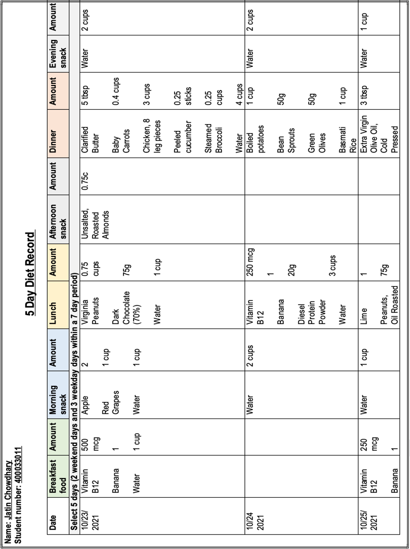

Appendix A: Diet Log (Page 2)
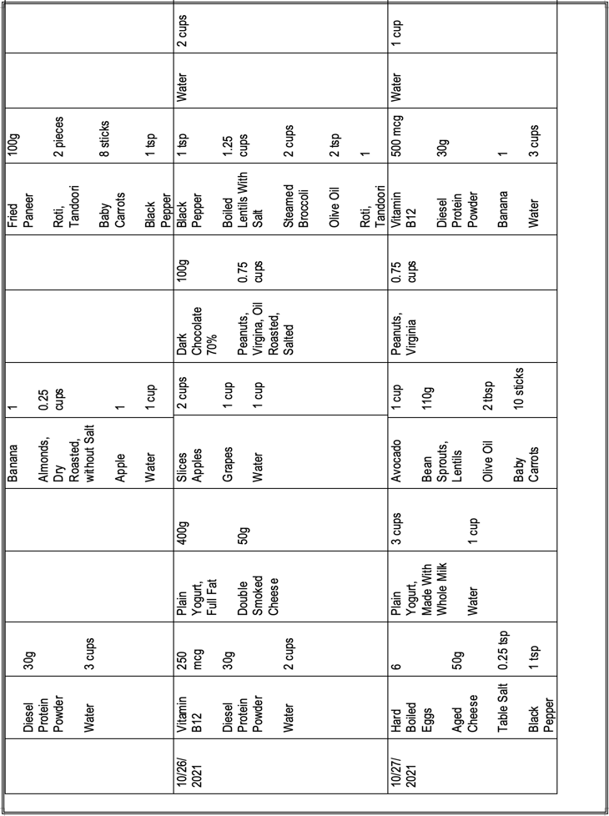

Appendix B: Daily Food Log (Day 1)
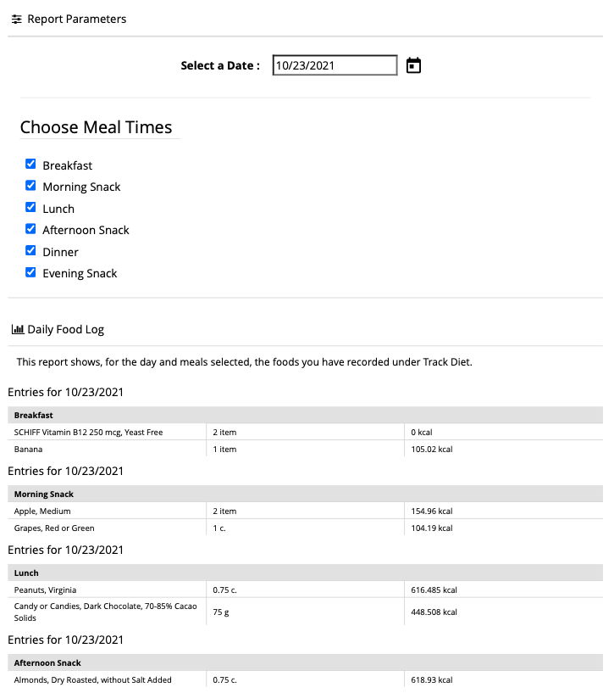
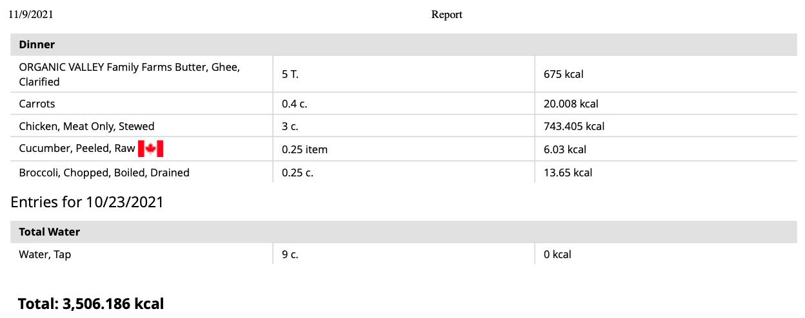

Appendix B: Daily Food Log (Day 2)
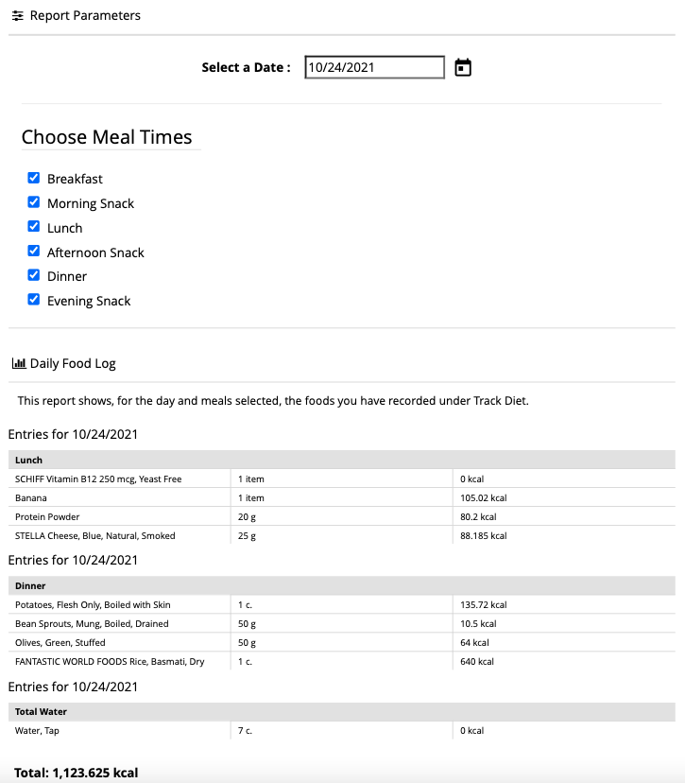

Appendix B: Daily Food Log (Day 3)
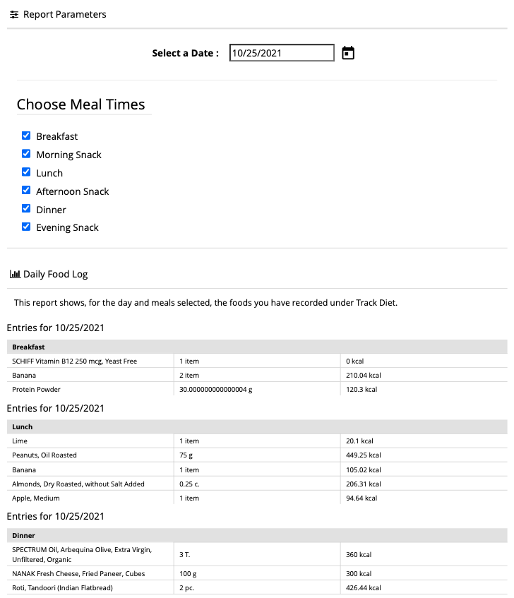
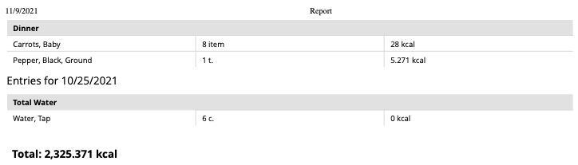
Appendix B: Daily Food Log (Day 4)
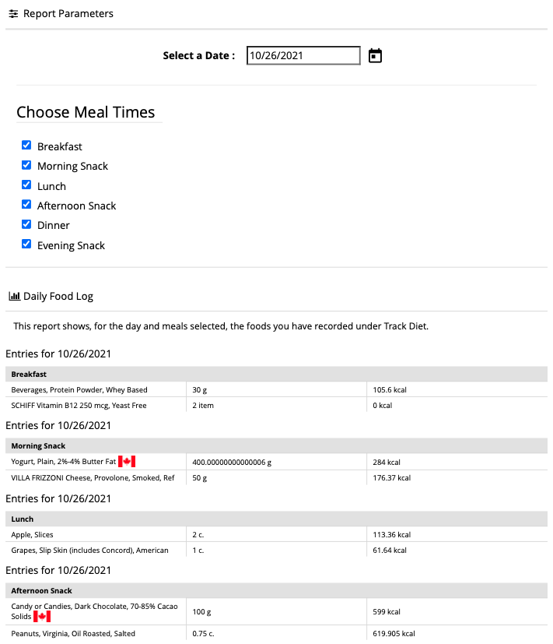
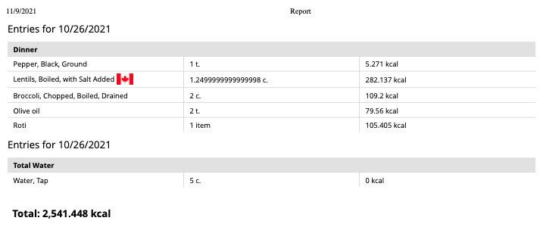
Appendix B: Daily Food Log (Day 5)
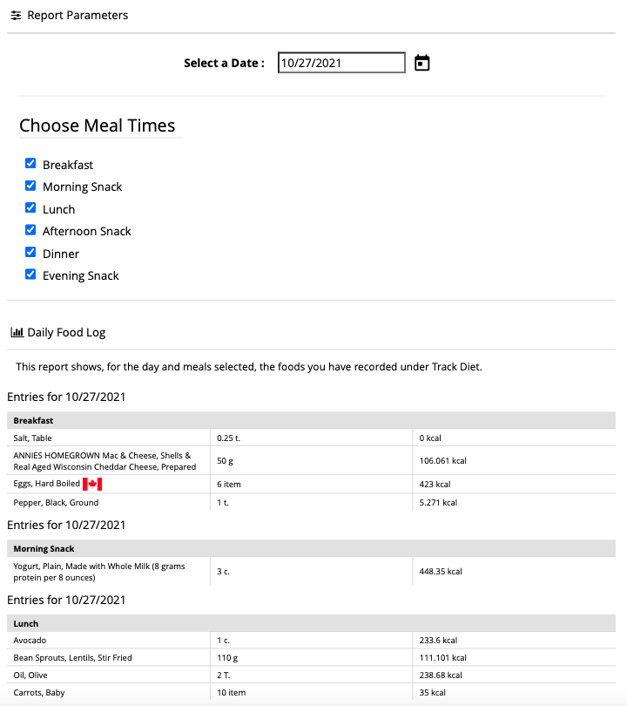

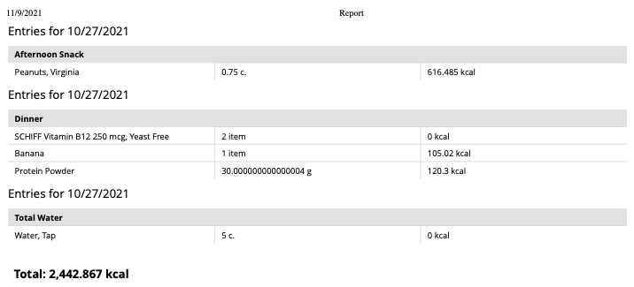

Appendix C: Data Abstraction Table (Page 1)
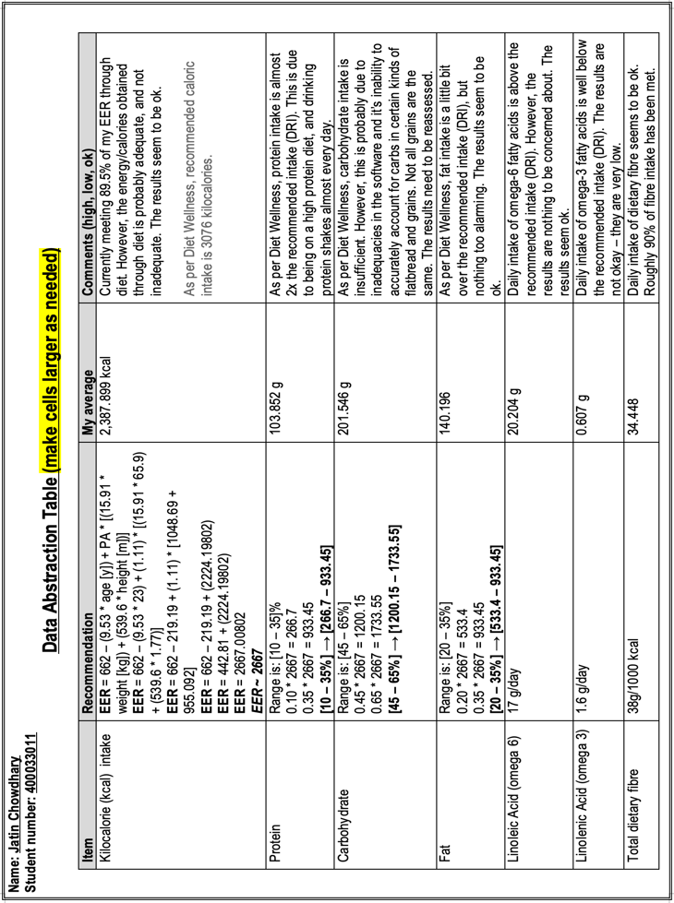

Appendix C: Data Abstraction Table (Page 2)
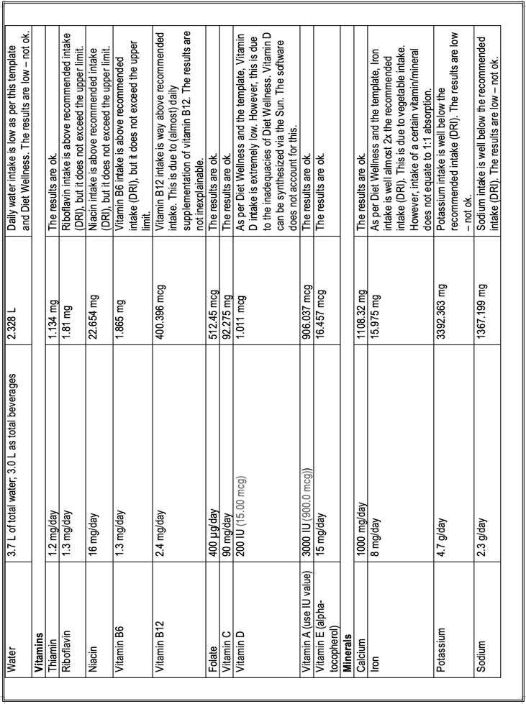

Appendix D: Back To Nature Croutons (Front)
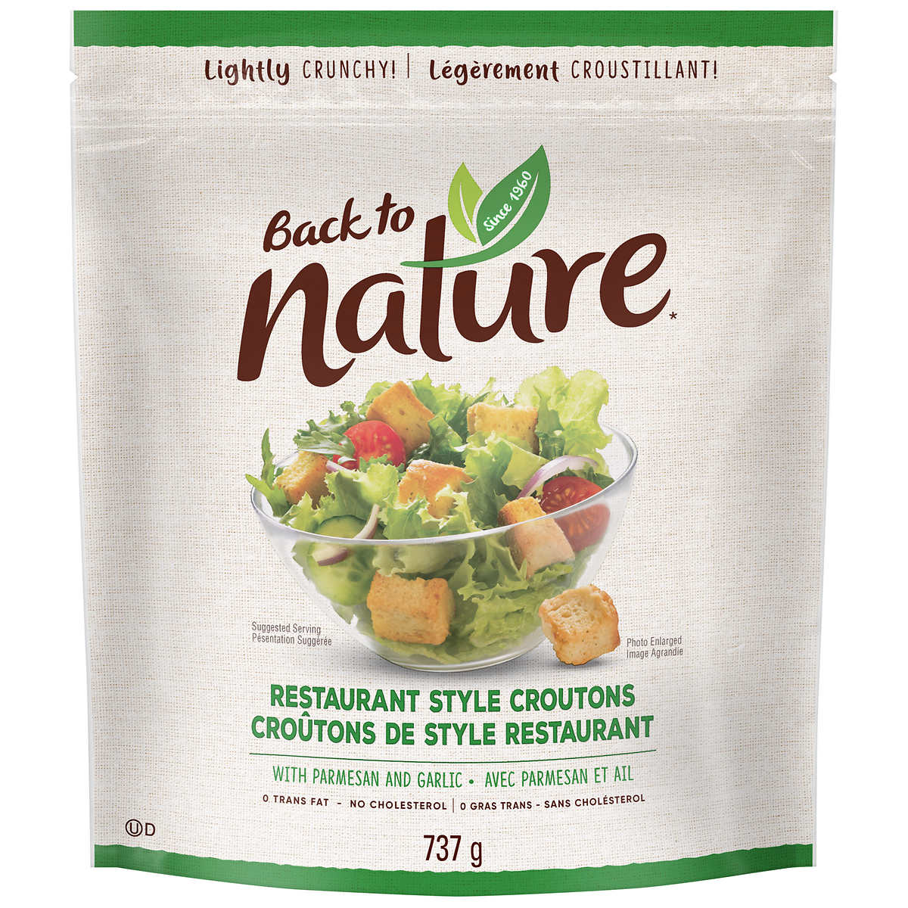

Appendix D: Back To Nature Croutons (Back)
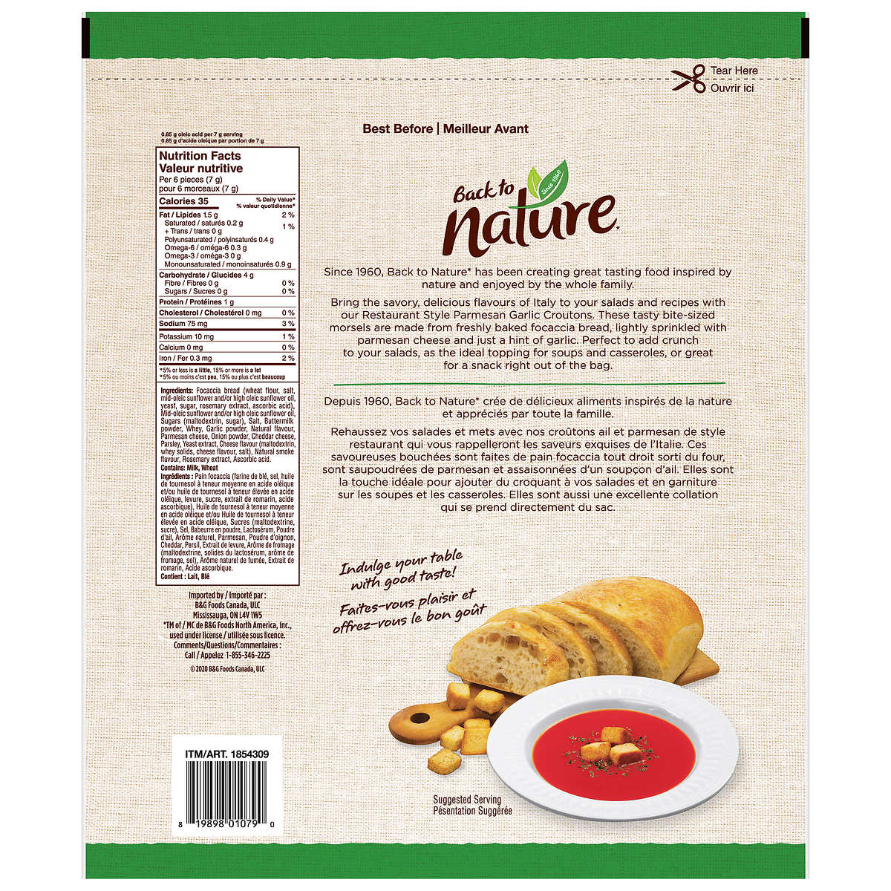

Appendix D: Keto Bombs (Front)
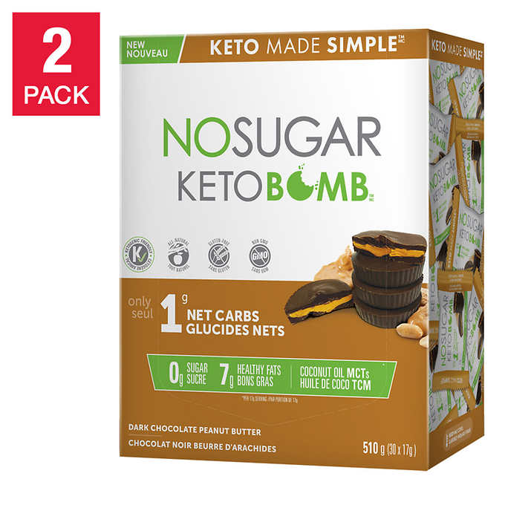

Appendix D: Keto Bombs (Back)
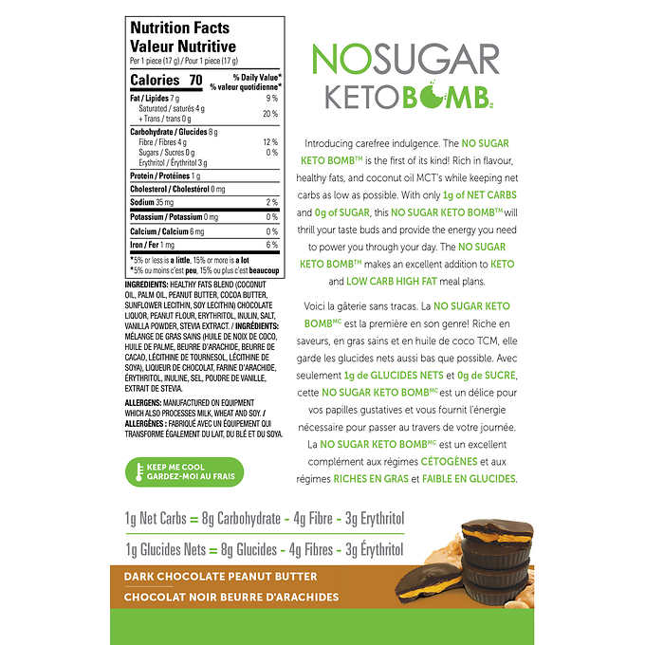

Appendix D: Welch's Fruit Snacks (Front)
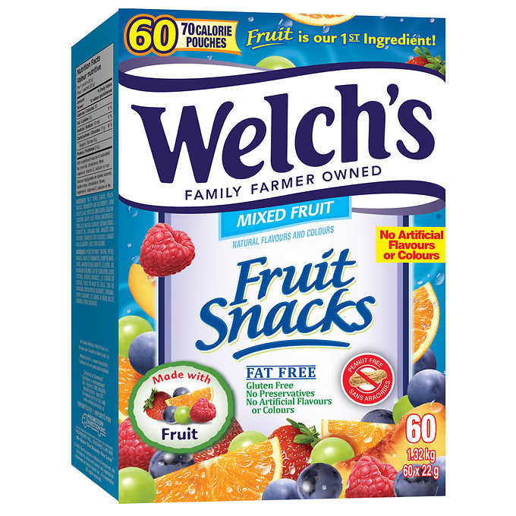

Appendix D: Welch's Fruit Snacks' Nutrition Label
